WINDOWS XP
You will work with Windows XP Professional because this is the desktop OS you’ll encounter in most organizations. You’ll learn its benefits, features, and weaknesses. You’ll install it, configure it, and customize it and you’ll learn to manage security for users. Finally, you’ll learn to troubleshoot common Windows XP Professional problems.
Benefits and Features - Very A+
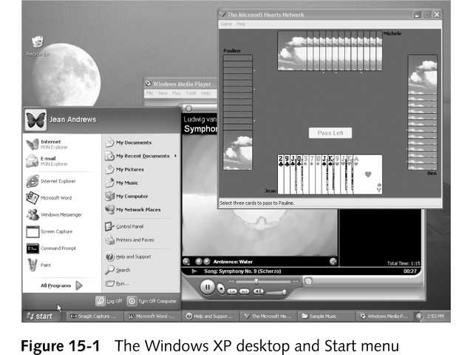
Desktop Beauty

Usability
It is an understatement to say that the default desktop is uncluttered, seeing as it contains only the Recycle Bin icon. The former desktop icons have been moved to a reorganized, two-column Start menu that can be customized to suit the needs and experience of the users.

When you make changes through the Display applet, you'll discover the improvements are more than just visual. The desktop seems to learn from you. Your Start menu constantly adjusts itself. Most frequently used programs are listed on the left side of the Start menu, with other programs available on the ALL programs submenu. The more you use a program, the higher it is on the list of frequently used programs.

The desktop reorganizes itself as well. If you have used earlier versions of Windows, you are probably familiar with cluttered desktops. Every program you install seems to place its own icon on the desktop. Windows XP solves this problem by periodically moving unused desktop icons into a folder named Unused Desktop Shortcuts. So even if every new program places a shortcut on the desktop, only the shortcuts you actually use stay on the desktop.

Speed
Windows XP is much faster than previous editions of Windows. Faster computers allow you to get more done -and can help lower your stress level. If your computer used to boot in one minute, it may now boot in under 40 seconds. CD creation is now much simpler.

Security
The process of setting NTFS permissions on files and folders in Windows XP Professional is identical to that for setting permissions on a Windows 2000 system.

Stability and Compatibility
Less hardware conflicts. Windows XP provides a compatibility mode. Older programs use a virtual OS. You can force XP to pretend that it is Windows 95 and force the required screen resolution and color depth. Simply pick it from a list. Window XP gives you the option to automate Windows updates. With the default setting, if a new patch is available it downloads the updates and a balloon message box pops up.

File System Support
Windows XP supports NTFS and has the same file support as in Windows 2000-that is, support for FAt12 for diskettes, and FAT16 and FAT32 for hard disks.

NTFS | FAT16 or FAT32 | FAT16
File and folder security | Setting up a dual boot with Windows 9x, and each OS must access all partitions | Setting up a dual boot with MS-DOS or Windows NT, and each OS must access all partitions
File Compression
Control over how much disk space a user is allowed
File encryption

Windows XP Weaknesses
Older devices that need drivers not supported by Microsoft-signed drivers. There are several commonly used pieces of software and hardware that do not work with XP. You may have to purchase a new video card and uninstall Symantec's Norton Utilities before upgrading to XP and then reinstall it after the upgrade.

Windows XP Requirements
Processor 233-MHZ, 600-MHZ recommended
64MB of RAM, 256 MB of RAM recommended
1.5GB of hard drive space, 4GB of hard drive space recommended
Video card that supports DirectX 8

A Fresh Start

Unless you erase your hard drive, reformat it, or delete partitions before the upgrade, data on the hard drive is not erased even you convert to a new file system during the installation. However, OS settings and installed software do not carry forward into the new installation.

Forgotten Your Password

Windows 2000/XP allows the currently logged-on user to create a Password Reset Disk that can be used in case of a forgotten password.

To create a Password Reset Disk.

- Need a blank, formatted floppy disk
- Open up User Accounts from Control Panel
- Select the account that you are currently logged on as, on the Pick a Task page

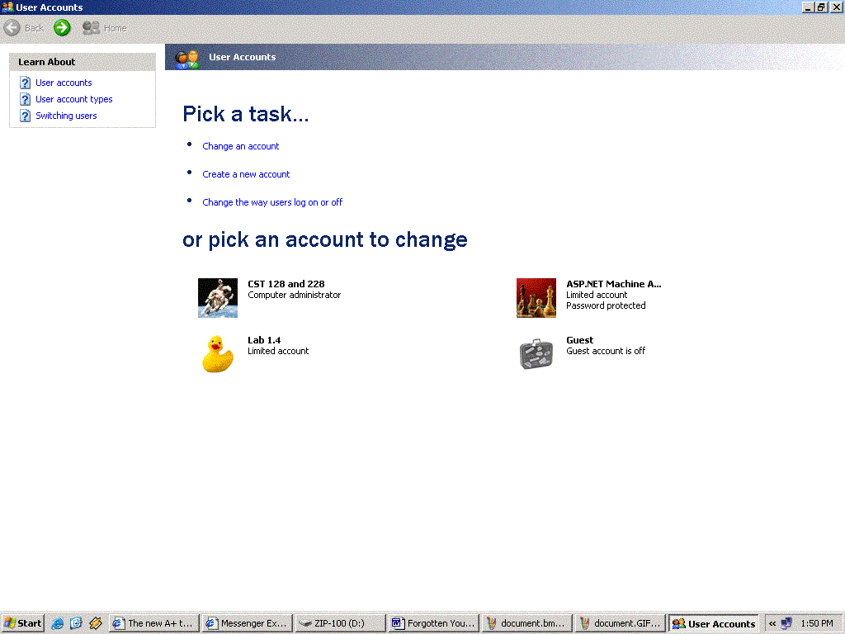

- On the next page, select Prevent A Forgotten Password from the list of Related Topics (on the left)

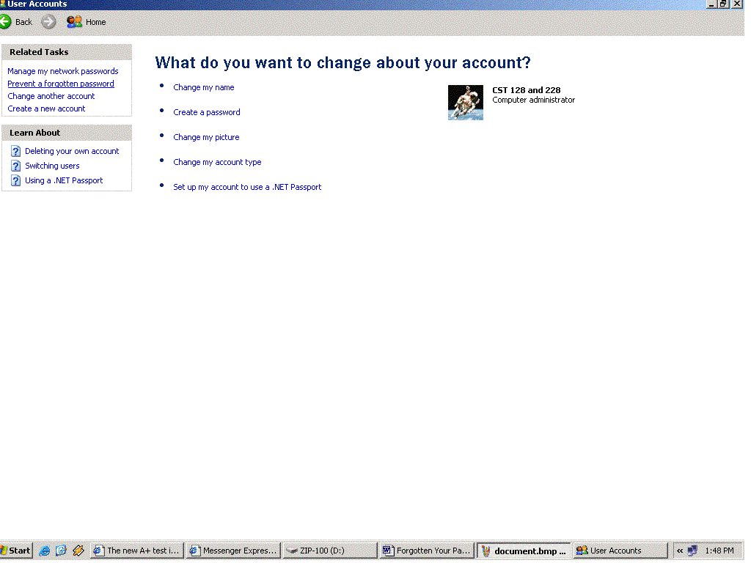

- Read the Welcome page of the Forgotten Password Wizard, and then click Next. Insert the disk in drive A: and click password and click Next. Now insert the disk in drive A: and click Next again to see the Create User Account Password page. Enter the current user account password and click Next. Sit Back and watch the progress bar!

The Boot Process

The boot process is the same, and the files needed for a successful boot are the same as this for Windows NT/2000.

- The computer’s processor (CPU) performs a few quick self-tests.
- The computer’s BIOS attempts to read the disk in the floppy drive. If there is no diskette present, it loads the first portion (sector) of the primary hard disk into memory and transfers execution to a small program contained there, which in turn locates the boot loader program, NTLDR. The boot loader’s primary function is to start the OS.
- When the boot loader program executes, it may display a boot loader screen, which lists the OS available on your computer and requests that you “Please select an OS to start.”
- After Windows XP is selected as the OS to start, the boot loader starts another program that detects the hardware present on your system. (At this point, you will be viewing the Windows XP logo on the screen.)
- The boot loader then starts Windows XP, or more precisely, a program known as the Windows XP kernel, NTOSKRNL. The kernel takes over the startup chores; for example, loading part of the Registry (more on Registry later) and device drivers into memory.
- Finally, the Logon phase of the startup process takes place. A Log on to Windows dialog box or the Welcome screen (depending on your configuration) will be displayed, asking you to enter your user name and password. After you do, the Windows Desktop will soon appear.

Troubleshooting Windows XP startup

The startup options (F8) are intended for use when something goes away in the startup process.

Error: Reference source not found

- First, try the Start Windows Normally option. Windows will try to start again, and sometimes does so successfully.

- Instead, select Last Known Good Configuration. Here, Windows XP will attempt to boot using the Registry information in effect at the last successful startup. If the startup problem was due to a configuration change made during the last Windows session, this option may do the trick. However, if the problem is a missing file or driver, Windows still will not boot.

- Next, try Enable Boot Logging. This option creates the Ntbtlog.txt file, which you (or a more experienced Windows user) can examine to try to determine the part of the startup process that is causing trouble.

- Finally, try starting Windows in Safe Mode.

If none of these suggestions works, try using Automated System Recovery.

Automated System Recovery –Very A+

ASR tool allows you to start Windows XP using a CD and a floppy and to restore it to a previous state. Be aware that ASR is a last resort. Use it only if all other attempts to start up Windows XP have failed. More on this later!

Window Messenger
By default, when Windows XP start, it loads Windows Messenger, which takes up system resources. To stop Windows Messenger from loading at startup, click Tools and then click Options. The Options window opens. Click the preferences tab and uncheck Run this program when Windows starts. Click OK.

Windows Media Player

Windows Media Player (WMP) is as powerful, multipurpose multimedia application. It can be used to
- Play audio CDs and DVD videos (if your computer has a DVD drive).
- Copy audio CDs to your hard disk.
- Create CDs (if your computer has a CD-RW drive).
- Download multimedia content from the Internet.
- Search for and organize the multimedia files on your hard disk.
- Play radio programs transmitted over the Internet.

The Remote Assistant Utility

This utility enables you to seek help with a computer problem from someone using a Windows XP computer on your local are network or connected to the Internet. You will work with this in Lab!

- Your computer becomes like a server and you may allow a user to "take over" your desktop from a remote location. There are clients written for each version of Windows. Servers are available in Win2K and XP.
- The Client is found at: Program Files \ Accessories \ Communications \ Remote Desktop Connection

Device Manager

In Windows XP, Device Manager works almost exactly as it did in Windows 2000, except that you can easily roll back a newly installed device driver to the previously installed driver.

To access the Rollback Driver button:
To revert to your previous keyboard driver
You must be logged on as an administrator or a member of the Administrators group in order to complete this procedure. If your computer is connected to a network, network policy settings may also prevent you from completing this procedure.
- Open Keyboard in Control Panel.
- On the Hardware tab, click Properties.
- On the Driver tab, click Roll Back Driver.
Ensuring the Integrity of System Files – A+

Windows XP uses a system of digital signatures to determine whether or not a critical system file has been altered or a new one has been installed that does not meet Microsoft’s standards. A digital signature is a special code applied to a file in such a way that the file cannot be altered without altering that code.

Files that do not have a digital signature –may or may not cause problems.

When you purchase a new software or equipment for use on your computer, you can ensure that the system-related files included with this product are digitally signed by looking for the “Designed for Microsoft Windows XP” logo on the package.

Windows XP Home and Professional Requirements - Very A+
- 233MHz Pentium (586). 300MHz recommended.
- 64MB of RAM (may limit performance and some features). 128MB recommended.
- 1.5GB of available hard disk space – you will of course need more if you want to install any applications
- The usual multi-media components

Windows XP Home and Professional Features - Very A+
http://www.microsoft.com/windowsxp/pro/howtobuy/choosing2.asp

Windows XP Home and Professional Upgrade Path
Previous Version | Windows XP  Home Edition | Windows XP  Professional
Windows 3.1 | NO | NO
Any Evaluation Version | NO | NO
Any Server Version* | NO | NO
Windows 95 | NO | NO
Windows 98/Windows 98 SE | YES | YES
Windows Me | YES | YES
Windows NT® Workstation 3.51 | NO | NO
Windows NT Workstation 4.0 | NO | YES
Windows 2000 Professional | NO | YES
Windows XP Home Edition |  | YES
Windows XP Professional | NO

Driver Signing - Very A+
The Driver Signing function allows Windows 2000/XP to notify users whether or not a device driver they are installing has passed the Microsoft certification process.
To modify the way driver signing operates, alternate click on "My computer", click on "Properties", select "Hardware" tab and click on the "Driver signing" button (right next to the new Device Manager button ;-).
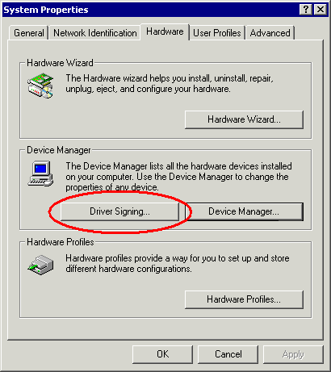
Very A+
If you suspect a problem with a driver, run Sigverif.exe from the Run dialog box
Driver signing has three basic modes of operation:
- Ignore - Allows all files to be installed, whether they've been signed or not.
- Warn - Notifies the user if a driver that's being installed hasn't been signed, and gives the user a chance to say "no" to the installation. Warn also gives the user the option to install unsigned versions of a protected driver file.
- Block - Prevents all unsigned drivers from being installed.
http://www.modemsite.com/56k/xpsign.asp

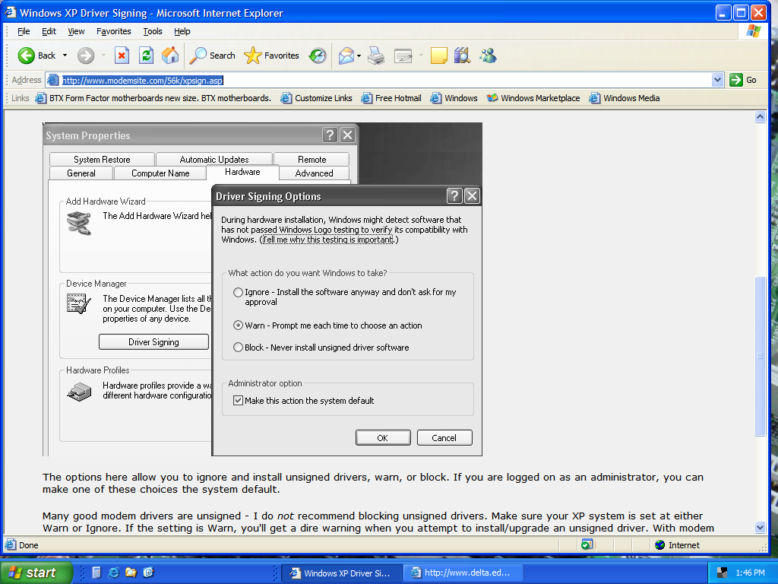

Windows 2000/XP ships with the Warn mode set as the default.
Roaming the System Properties Page
System properties in Win2K and XP offers us some new features and some twists on some old ones.
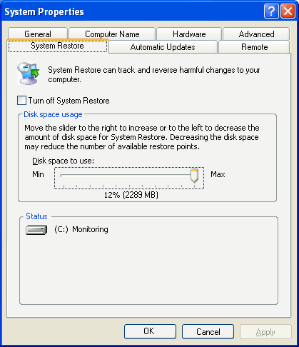
XP Note that the Windows XP Properties Page has additional features. Let’s take a look at what’s behind them.

