**CST-133W “Turn-In” Instructions**

**HTML5 Lab**

Work your way through the lab PDF ([link](http://www3.delta.edu/cstfiles/CST-133/cst133_labPDFs/HTML%20Lab/html5_css_illust_unit_b_gettingstartedwithhtml.pdf)) by reading and following the directions. Using Notepad, do the first 5 exercises. There are no Print Screens for this lab. Be sure to save your file as **index.html** – **nothing else will do!!** Plan to post your web page to your web space and your instructor will view it on the web.

1. Read through “Assessing the History of HTML” and “Comparing HTML and XHTML” on pages 26-29.
2. Do the exercises for building your web page on pages 30-33.
3. On page 34, steps 1 and 2 refer to **Lakeland Reeds Bed and Breakfast**. Replace Lakeland Reeds with your name. Example: <title>Annie Student’s Bed and Breakfast</title>. When you get to step 4, type your name as the Proprietor and skip step 5.
4. When you finish the exercises, copy your index.html file to the Internet in your own web space. Start Internet Explorer and navigate to ftp://student.delta.edu . When the following dialog box will pops up, enter your Delta username and password (not Mikes).

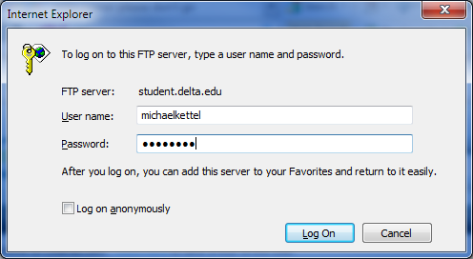

1. This will bring you to your Internet Browser window. Follow the directions on the screen: click on the **Page** tab on the top right, choose **Open FTP site**, click Allow if prompted, and then enter your Username and password and password again.
2. Adjust your Internet Browser Window so that it is side by side to the folder containing your index.html file. Make your screen look like the one below. Copy (drag and drop) the index file to your Internet Browser Window. Keep in mind you can delete, rename and copy files in the Browser Window as needed.

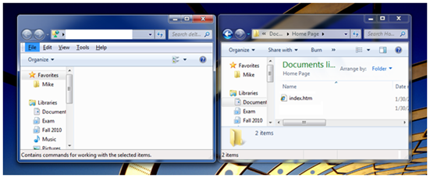

**Remote Local**

1. With the index file copied, navigate to your web site to view your new page: student.delta.edu/anniestudent Remember to use your name.
2. Create a new Word Document and type the line: My website is complete! Hoo! Hoo! Hoo! Please view it at: http://student.delta.edu/yournamehere.

***Submit this one document containing the link to your web page as directed by your instructor.***