**CST-133W “Turn-In” Instructions**

**Web Media Lab**

Work your way through the lab PDF ([link](http://www3.delta.edu/cstfiles/CST-133/cst133_labPDFs/Web%20Media%20Lab/web2.0unit_b_finding_media_for_projects.pdf)) by reading and following the directions. When you get to the 5 pages listed below, do a Print Screen, and then paste your image into this document.

As you complete a section, delete all the blue print and graphic examples then paste your own graphics into this document, but leave the black text. Save this file on your USB drive as Web Media Lab and submit it as directed by your instructor.

**Read through the information on “Understanding Copyright”**

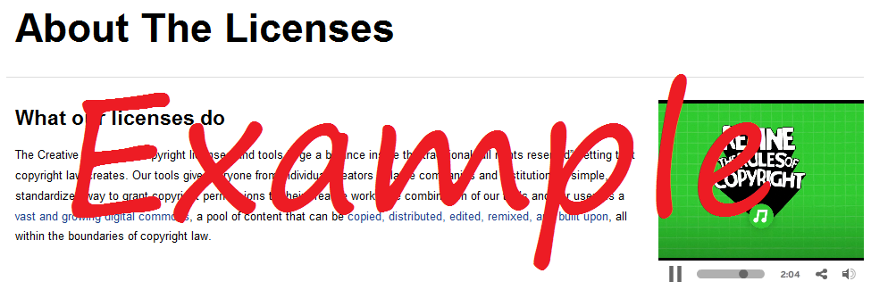**Page 26:** Creative Commons**:** When you complete step 6 view the video on Creative Commons. Capture the screen showing the video in progress as shown in this example image. Insert it to replace the image below and then right-click on your image and choose **Text Wrapping** - **tight**.

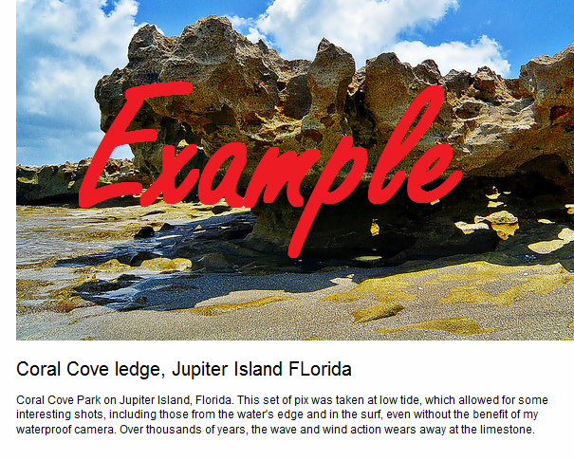**Page 28:** Finding Images**:** When you complete step 4, capture the screen showing the picture of coral you clicked on and insert your image here. Finish the exercise.

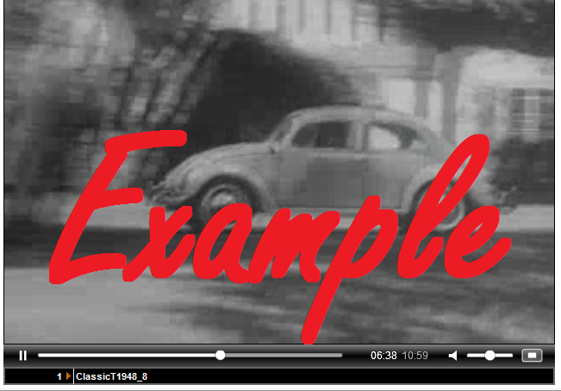

**Page 30:** Finding Video**:** When you complete step 5, capture the screen showing the commercial you liked the best.

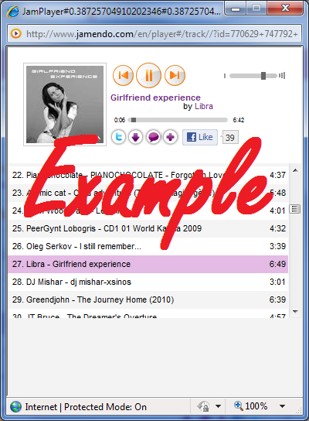**Page 32:** Finding Music**:** When you complete step 4, capture the screen showing the music you listened to.

**Read through the section on “Obtaining Permission and Crediting Sources” and “Understanding Terms of Use”**

**Page 38:** Posting Files Online**:** When you complete step 2, capture the screen showing the photo you saved and the description you typed. Complete the exercise.

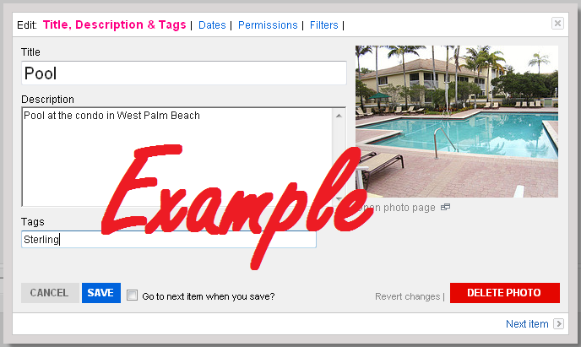

**Read through the section on “Protecting the Rights to Your Work”**

***Submit this one document containing the 5 images as directed by your instructor.***