**CST-133W “Turn-In” Instructions**

**Windows Files and Folder Mgmt Lab**

** Before beginning this lab make sure you have downloaded and unzipped the data files for the CST 133 labs from the following site:

<http://websites.delta.edu/cstfiles/cst-133/lab_datafiles/cst133_datafiles.zip>

You should install these files on your USB drive. If you have already done this, you not need to complete this step again.

Open the Unit C and D PDF’s ([link](http://www3.delta.edu/cstfiles/CST-133/cst133_labPDFs/Files%20and%20Folder%20Mgmt%20Lab/)) and follow the directions. You must be running Windows 7 for this lab. When you get to the 16 pages listed below, do a Print Screen, and then paste your images into this document. You will submit this document for grading as instructed by your instructor.

As you complete a section, delete all the blue print and graphic examples, then paste your own graphics into this document, but leave the black text. Save this file on your USB drive as Lab Assignment #1 and submit it as directed. Type your name on the third line of the title of this document.

**Unit C: Managing Files and Folders**

**Page 50:** Opening Windows Explorer**:** When you complete step 7, capture the screen, paste it into Paint, crop it and then paste it below to replace the example image. Right-click on your image and choose **Text Wrapping**, **tight** so that you can move it more freely in the document.

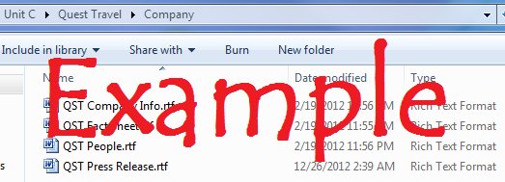

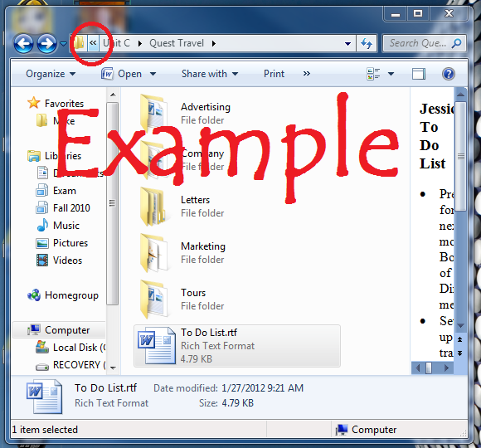**Page 52:** Viewing Files and Folders**:** When you complete step 9, capture the screen, and paste it into Paint. Crop your image and then paste it here to replace the example image. Your image should look similar to the example.

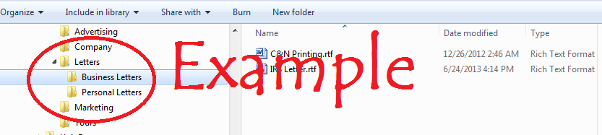**Page 54:** Navigating a Folders List**:** When you complete step 7, capture the screen, and paste it into Paint.

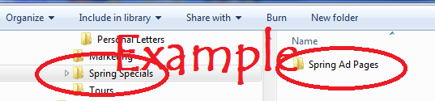**Page 56:** Creating and Renaming**:** When you complete step 5, capture the screen, and paste it into Paint. Be sure to finish the exercise.

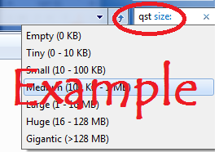**Page 58:** Searching for Files**:** You should be in the **Quest Travel** folder. When you complete step 5, capture the screen showing the search box menu for size. Be sure to finish the exercise.

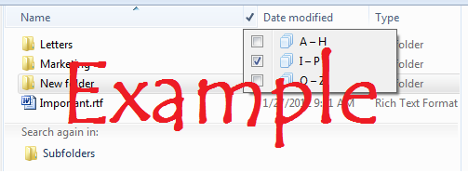**Page 60:** Organizing Files**:** You should be in the **Quest Travel** folder. When you complete step 5, capture the screen showing the I-P filter as shown in the example. Be sure to finish the exercise.

**Page 62:** Copying and Moving Files**:** You should be in the **Quest Travel** folder. You may want to “right-click and drag” your files. When you complete step 6, capture the screen showing that you copied **QST New Logo.bmp** as shown in the example.

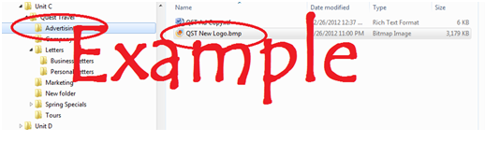

**Page 64:** Deleting and Restoring Files**:** You should be in the **Quest Travel/Letters/Personal Letters** folder. When you complete step 6, capture the screen showing the Restore button of the Recycle Bin. Be sure to complete the exercise.

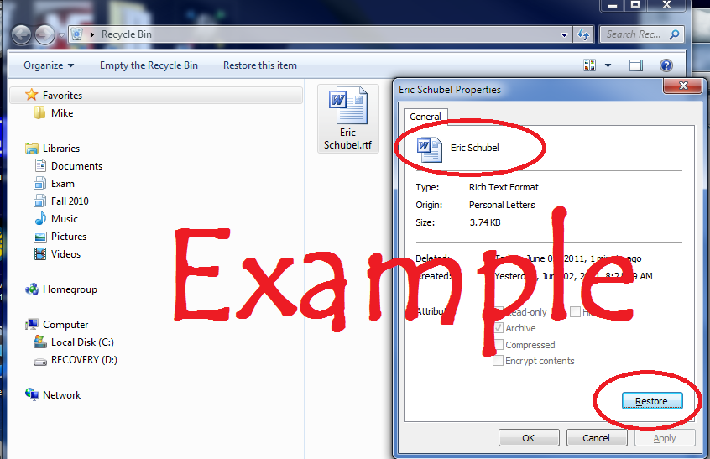

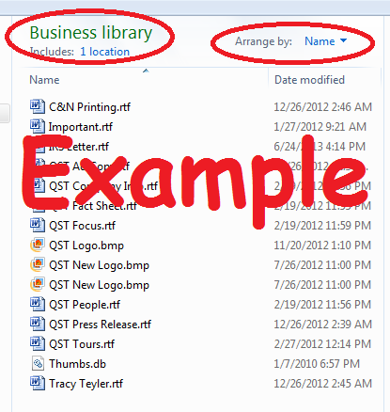

**Page 66:** Working with Libraries**:** When you complete step 4, capture the screen as show here.

**Unit D: Customizing File and Folder Management**

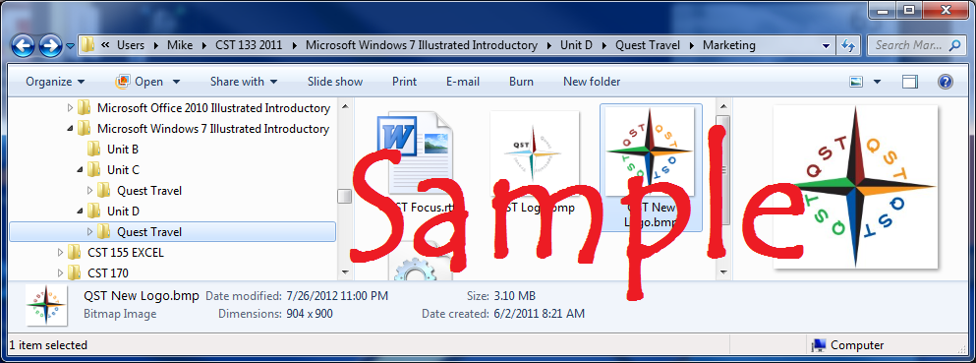**Page 74:** Changing the Layout**:** When you complete step 6, capture the screen showing the Logo in the Preview Pane. Be sure to complete the exercise.

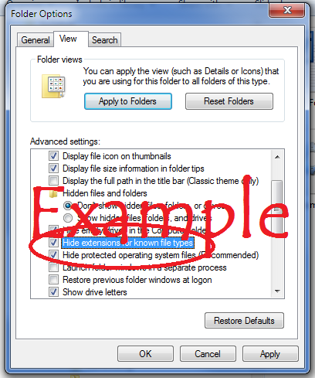

**Page 76:** Changing Folder Options**:** When you complete step 6, capture the screen showing the Folder Options. Be sure to complete the exercise.

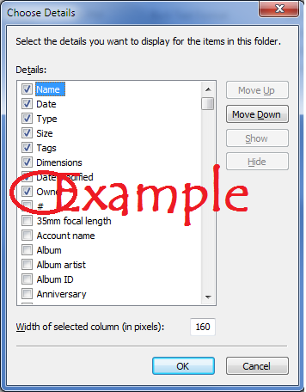

**Page 78:** Changing File Details to a List**:** When you complete step 8 on page 6, capture the screen showing the Owner check box.

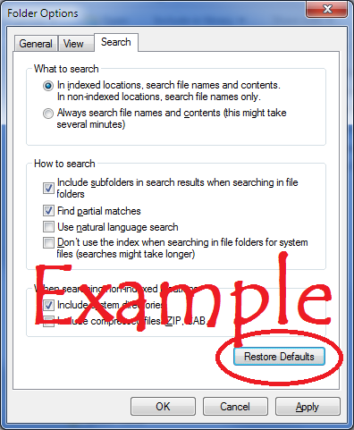**Page 80:** Changing Search Options**:** When you complete step 8, capture the screen showing the Restore Defaults button. Be sure to complete the exercise.

**Page 82:** Using Personal Folders**:** When you complete step 7, capture the screen of your video.

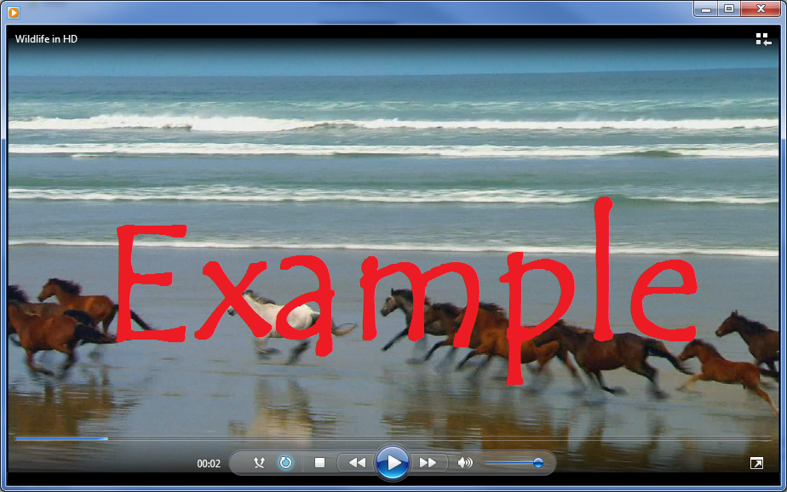

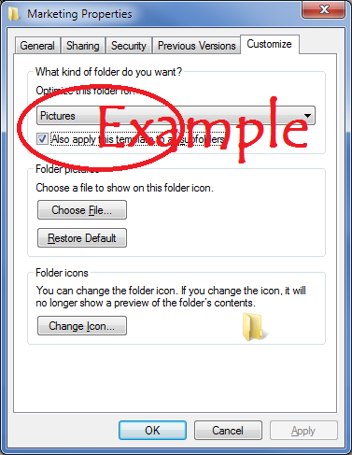**Page 84:** Customizing Personal Folders**:** When you complete step 4, capture the screen of the **Marketing Properties dialog box** .

**Page 86:** Display Disk and Folder Information**:** When you complete step 8, capture the screen of Travel Quest Properties box.

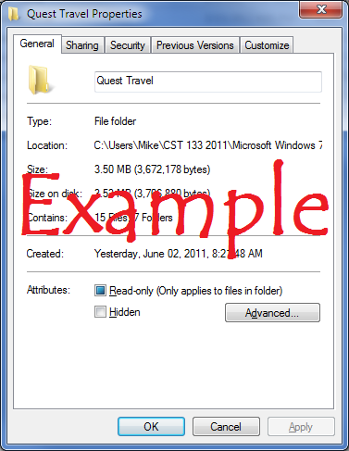

**Page 88:** Compressing Files**:** When you complete step 8, capture the screen showing the Extract dialog box. Be sure to complete the exercise. Skip page 76.

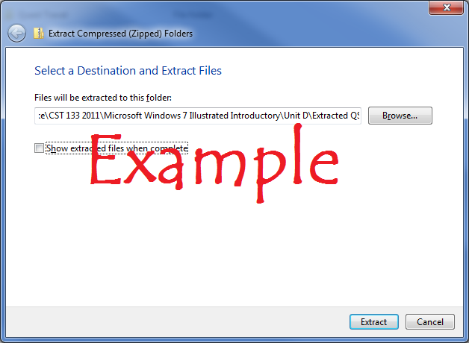

***Submit this one document containing the 16 images as directed by your instructor.***

***If required to submit via a D2L dropbox, follow these directions:***

1. Start D2L and navigate to your CST 133 course
2. Click on the **Content** tab or the **Dropbox** tab
3. Locate and click the link for the appropriate drop box.
4. Optional: Click in the Comments box and type a message to me.
5. Click the **Add a File** button
6. Click the **Browse** button
7. Navigate to the file you wish to submit and click on it
8. Press the **Upload** button
9. Scroll to the bottom of the page and press the **Submit** button
10. When you see the message **“File Submission Successful”** you will know that all went well, and you are finished.
11. Refer to these directions for all the other labs.