**CST-133W “Turn-In” Instructions**

**Internet Lab**

Work your way through the lab assignment PDFs ([link](http://www3.delta.edu/cstfiles/CST-133/cst133_labPDFs/Internet%20Lab/)) by reading and following the directions. When you get to the 18 pages listed below, do a Print Screen, and then paste your image into this document.

As you complete a section, delete all the blue print and graphic examples then paste your own graphics into this document, but leave the black text. Save this file on your USB drive as Browser Lab and submit it as directed at the end of the assignment. Type your name on the third line of the title of this document.

**Unit B: Understanding Browser Basics**

**Page 30:** Browser Basics**:** When you complete step 4, capture the screen showing the New Tab. Paste it into Paint and label the Title Bar, Menu Bar, Address bar, Tabs, Search box, Status bar and Back, Refresh, Home and Stop buttons. Insert it to replace the image below and then right-click on your image and choose **Text Wrapping** - **tight**.

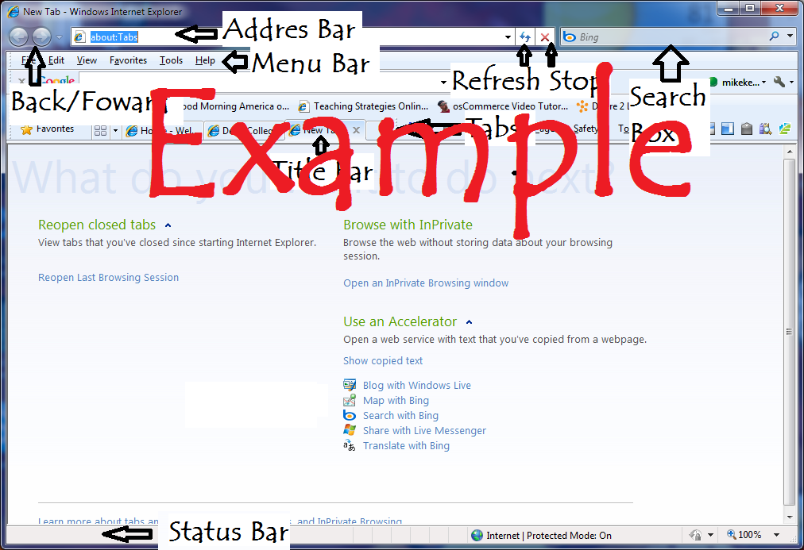

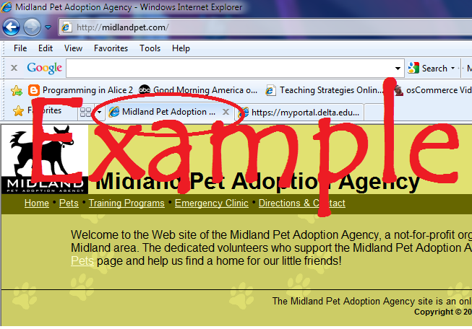

**Page 32:** Web Sites**:** When you complete step 4, capture the screen showing midlandpet.com as your first tab. Paste it into this document.

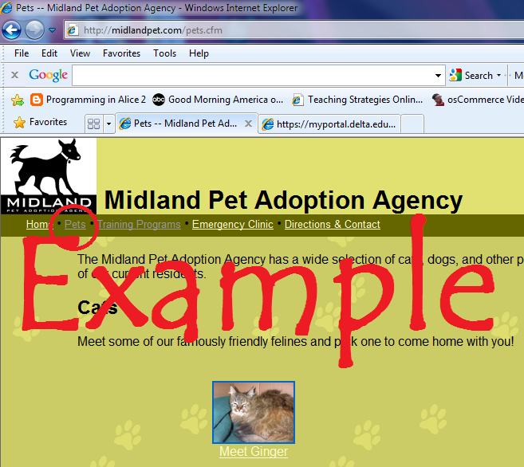

**Page 34:** Navigating Web Sites**:** When you complete step 9, capture the screen showing the **Pets** link. Paste it into this document.

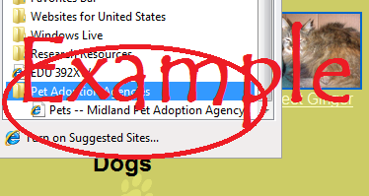

**Page 36:** Favorites**:** When you complete step 7, capture the screen showing **Pets** in your Favorites Center. Paste it into this document.

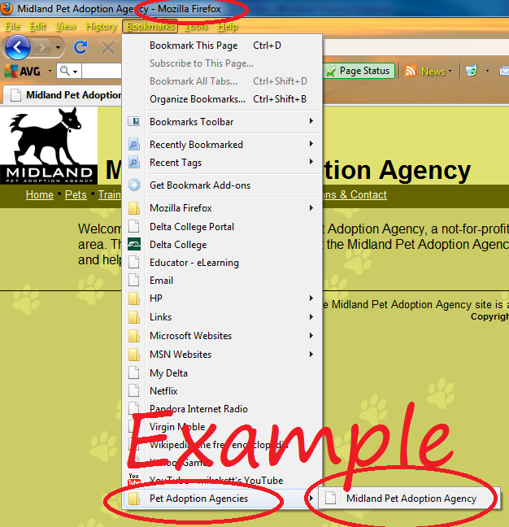**Page 38:** Firefox**:** When you complete step 9, capture the screen and past it into this document.

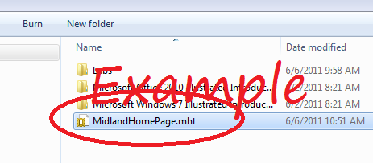

**Page 40:** Saving a Web Site**:** When you complete step 8, capture the screen showing your saved document**.** Paste it into this document. Be sure to finish the exercise.

**Page 44:** Copying Text and Graphics**:** When you complete step 9, capture the screen showing your two new files. Paste your image here as shown.

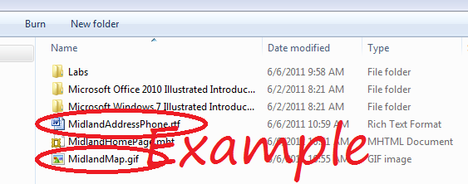

**Unit D: Searching the Web**

**!!!!!! The “Online companion” for Unit D can be accessed at:**

[**http://oc.course.com/illustrated/internet6/**](http://oc.course.com/illustrated/internet6/) **(Click on Unit D once you access the site.)**

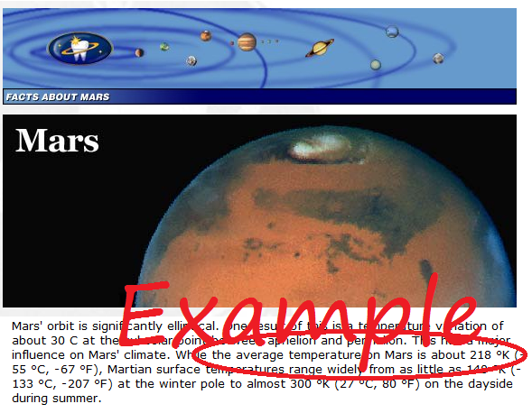

**Page 98:** Search Engines**:** When you complete step 8, capture the screen showing **the average temperature on Mars.**  Paste it here as shown.

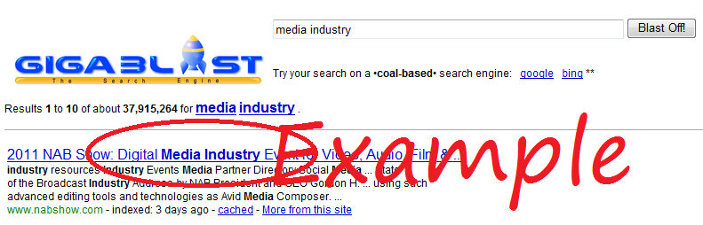**Page 100:** Web Directory**:** When you complete step 4, capture the screen showing **links to the Media Industry.**  Paste it here as shown.

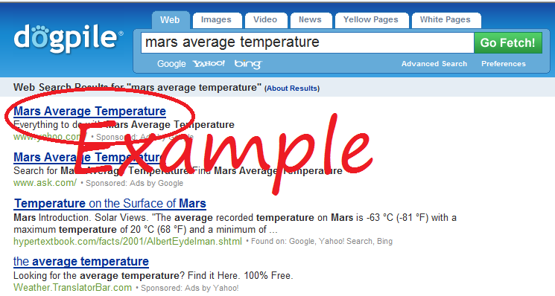**Page 102:** Metasearch Engine**:** When you complete step 4, capture the screen showing **your metasearch.**  Paste it here as shown.

**Page 104:** Subject Guide**:** When you complete step 5, capture the screen showing **your Subject Search.** Paste it here as shown.

**Read through “Understanding Advanced Searching Techniques”**

**Page 108:** Advanced Search**:** When you complete step 6, capture the screen showing **your Advanced Search.**  Paste it here.

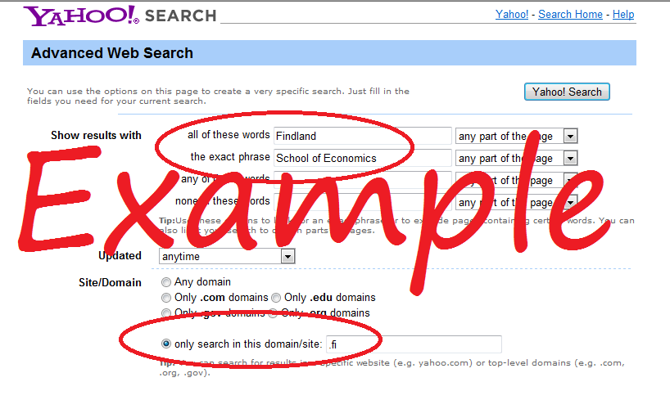

**Page 110:** Boolean Operators**:** When you complete step 2, capture the screen showing your Boolean Operator **“OR”.**  Paste it here as shown.

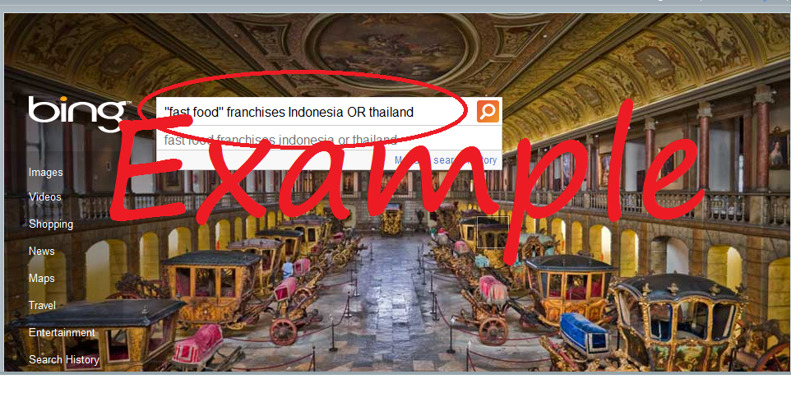

**Unit E: Getting Information from the Web**

**!!!!! The “Online companion” for Unit E can be accessed at:**

[**http://oc.course.com/illustrated/internet6/**](http://oc.course.com/illustrated/internet6/) **(Click on Unit E once you access the site.)**

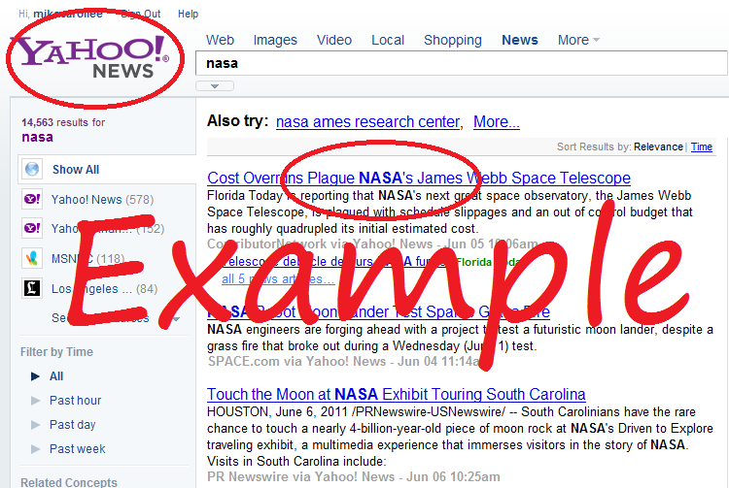**Page 118:** Getting the News**:** When you complete step 3, capture the screen showing your **News Search of NASA.**  Paste it here as shown.

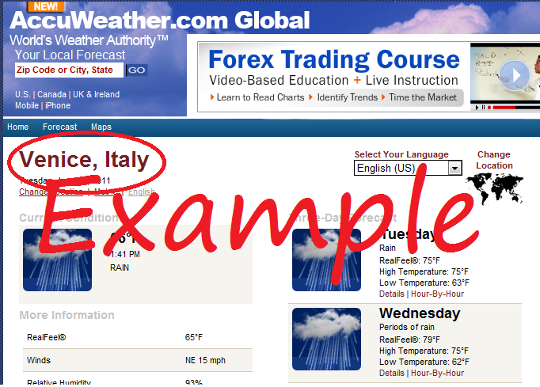**Page 120:** Getting the Weather**:** When you complete step 7, capture the screen showing the **weather in Venice, Italy.**  Past it here as shown.

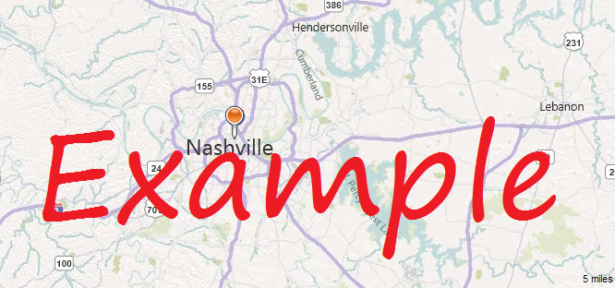**Page 122:** Getting Maps**:** When you complete step 5, capture the screen showing a map of **Nashville TN.**  Paste it here as shown.

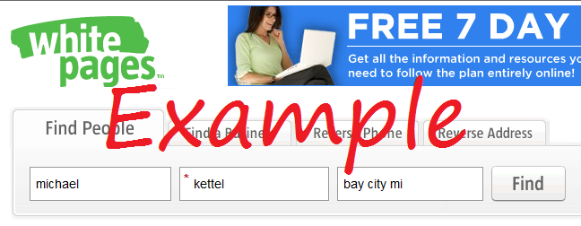**Page 124:** People Search**:** When you complete step 10, capture the screen showing a **search on your name.**  Paste it here as shown.

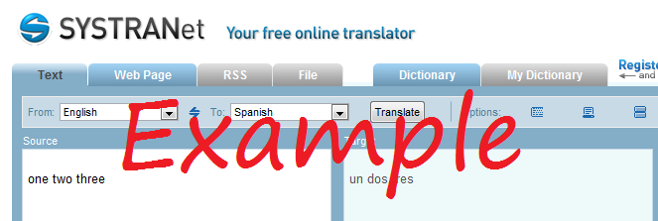**Page 126:** Online Translator**:** When you complete step 10, capture the screen showing a **translation from one language to another.**  Paste it here as shown.

**Read through the sections on “Evaluating Web Resources,” “Evaluating User-Generated Content,” and “Understanding Copyright and Citing Web Resources.”**

***Submit this one document containing the 18 images as directed by your instructor.***