CST 126 - Lab 8
(Chapter 7)
Name: Date:

Learning Objectives
    - To learn how to create a UNIX file structure (i.e., directory hierarchy)
    - To learn about absolute and relative pathnames
    - To learn about home directory, login directory, and present working directory (also known as the current directory)
    - To learn how to effectively navigate the UNIX directory hierarchy
    - To learn about file types and hidden files
    - To learn about the file attributes

Lab Work
Most of the work you will do in this lab will be related to the following directory hierarchy.
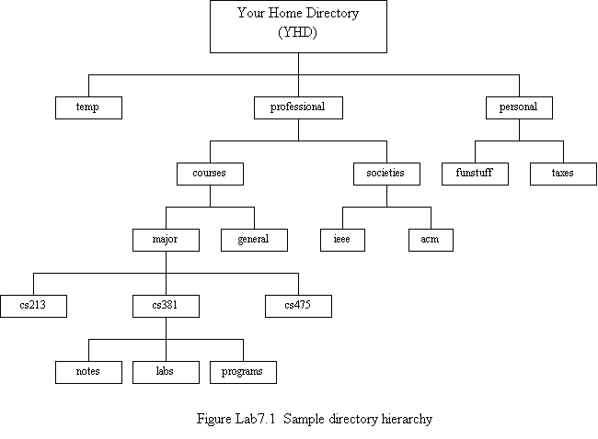
lab8

Sample Directory Hierarchy

- Log on to your UNIX system
- Build the above directory hierarchy under your home directory, starting with the subdirectory labeled as lab8. (Hint: use the ‘mkdir’ command and build the structure one leg at a time. Use the cd command and the dot-dot designation to move up your directory structure. Use the pwd command to make sure you are where you think you are before creating the subdirectories.)
- After you complete the structure, cd to the LAB8 subdirectory, and use the following command to output a complete listing of the subdirectories and files to a separate file:
$ ls –alR > lab8_directory

Print the lab8_directory file and attach it to this lab for turnin.

- Record the absolute pathname of your login directory.

- Suppose that after login, you execute the “cd lab8/professional/courses” command. Answer the following questions.
  - What is the absolute pathname of your home directory? Show the command that you used to obtain the answer to this question, along with the command output.

  - What is the absolute pathname of the ‘acm’ directory?

  - Give two relative pathnames for the ‘acm’ directory.

  - Execute the “cd major/cs381/labs” command. Now execute a command to display the absolute pathname of your current directory. Record the command.

  - Give three different commands to get back to your home directory.
- Change directory to /usr. How many directories are there in this directory? Are there any symbolic links? Record the listing for the links.

- The /etc directory also contains a file that contains attributes for all the users who have accounts on the system. A line in this file describes the user. What is the name of this file? Display the line for yourself and display the session below. Also write down the following information about yourself: user name, user ID, group ID, personal information, home directory, and login shell.

- What are the inode numbers of the following directories on your system: your home directory, ~/lab8/temp, ~/lab8/professional, and ~/lab8/personal?

- Log out.

