CST 134 – Restaurant Supply Database Project Assignment

Restaurant Supply Database is divided into 3 parts.
- Part 1: - Create tables and form
- Part 2: - Create queries
- Part 3: - Create queries and reports

Problem:
A distributor supplies local restaurant with non-food supplies such as napkins, paper towels, and cleaning supplies. The distributor employs sales representatives who receive a base salary as well as a commission on sales. The database consists of two tables. The Customer Table contains information on the restaurants that buy supplies from the distributor. The Sales Rep table contains information on the sales representative assigned to the restaurant account.
- Part 1: - Create tables and Form
Instructions:
- Create a new database in which to store all objects related to the restaurant data. Call the database Restaurant Supply.
- In this database, you will create 2 tables called: Customer and Sales Rep.
- Create the “Customer” table.
  - Customer table structure provided in table 1.
  - Add customer records as shown in table 1.
- Print the Customer table as a proof you complete Customer table.
- Create the Sales Rep table.
  - Sales Rep table structure provided in table 3.
  - Add Sales Rep records as shown in table 4.
- Print the Sales Rep table.
Table 1: Structure for Customer table
Field name |  | Data Type |  | Field Size | Primary Key |  | Input Mask |  | Description
Customer Number |  | Text |  | 4 | Yes |  |  |  | Customer Number
Name |  | Text |  | 20 |  |  |  |  | Name of customer
Address |  | Text |  | 15 |  |  |  |  | Street Address
Telephone |  | Text |  | 8 |  |  | 000-0000
Balance |  | Currency |  |  |  |  |  |  | Amount Currently Due
Amount Paid |  | Currency |  |  |  |  |  |  | AMount Paid Year-to-Date
Sales Rep Number |  | Text |  | 2 |  |  |  |  | Number of Sales Representative
Table 2: Data for Customer table
Customer Number | Name |  | Address |  |  | Telephone |  | Balance |  | Amount Paid | Sales Rep Number
AM23 | American Pie |  | 223 Johnson |  |  | 555-2150 |  | $95 |  | $1,595 | 44
BB34 | Bob's cafe |  | 1939 Jackson |  |  | 555-1939 |  | $50 |  | $0 | 51
B115 | Bavarian Inn |  | 3294 Devan |  |  | 555-7510 |  | $445 |  | $1,250 | 49
CB12 | China Buffet |  | 1632 Clark |  |  | 555-0804 |  | $45 |  | $610 | 49
CM09 | Curry and More |  | 3140 Halsted |  |  | 555-0604 |  | $195 |  | $980 | 51
EG07 | El Gallo |  | 1805 Broadway |  |  | 555-1404 |  | $0 |  | $1,600 | 44
JS34 | Joe's Seafood |  | 2200 Lawrence |  |  | 555-0313 |  | $260 |  | $600 | 49
LV20 | Little Venice |  | 13 Devon |  |  | 555-5161 |  | $100 |  | $1,150 | 49
NC25 | New Crete |  | 1027 Wells |  |  | 555-4221 |  | $140 |  | $450 | 44
RD03 | Reuben's Deli |  | 787 Monroe |  |  | 555-7657 |  | $0 |  | $875 | 51
VG21 | Veggie Gourment |  | 1939 Congress |  |  | 555-6554 |  | $60 |  | $625 | 44

Table 3: Structure for Sales Rep table
Field name | Data Type | Field Size | Primary Key | Description
Sales Rep Number | Text | 2 | Yes | Sales Rep Number
Last Name | Text | 15 |  | Last Name of Sales Rep
First Name | Text | 10 |  | First Name of Sales Rep
Address | Text | 15 |  | Street Address
City | Text | 15
State | Text | 2
Zip Code | Text | 5
Salary | Currency
Comm Rate | Number | Double |  | Commission Rate
Commission | Currency |  |  | Year-to-date Total Commisions

Table 4: Data for Sales Rep table
Sales Rep Number | Last Name | First Name | Address | City | State | Zip code | Salary | Comm Rate | Commission
44 | Charles | Pat | 43 4th | Lawncrest | WA | 67845 | $19,000 | 0.05 | $213.50
49 | Gupta | Pinn | 6 Hillcrest | Manton | OR | 68923 | $20,000 | 0.06 | $216.60
51 | Ortiz | Jose | 9 Main | Lawncrest | WA | 67845 | $18,500 | 0.05 | $92.75
- Make sure the Customer table is selected. Create a new form in design view, similar to the following, for the Customer table.
- While working in design view, create the Form header and add the button commands as shown below. (Hint: When you add the buttons, use the pop-up wizard to guide you to the shown record operations.)
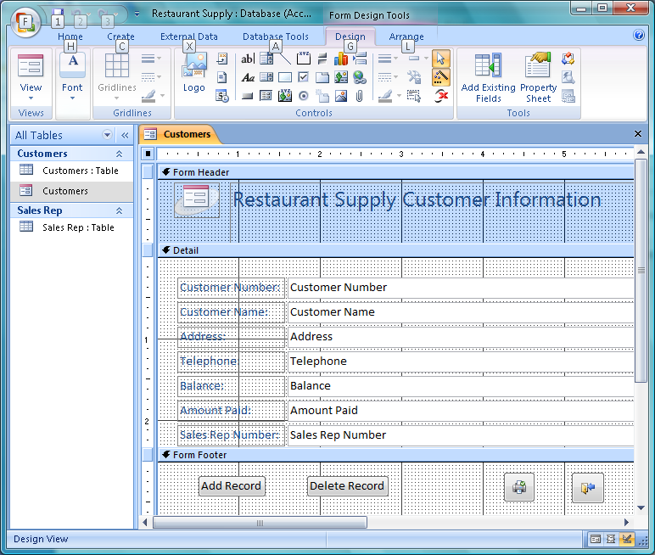
- How to add button commands:
  - Select command icon in the toolbox and drag it under the Form Footer. The following wizard will launch automatically. Choose the category and then the required action.

  - 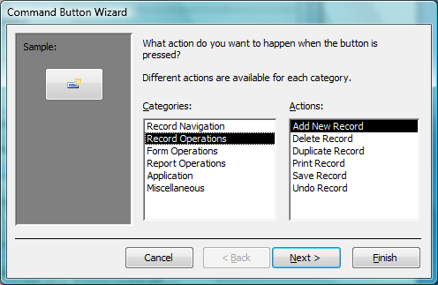

  - Click Next. You can select either Text or Picture on the button. Select text for "Add New Record" and "Delete Record" buttons and pictures for Print and Exit icon.
  - Click Next and then click Finish
  - Follow the same steps to create other 3 command buttons .
- Save the form and name it as Customer. Pull down View and switch to Form View.
- Add the new customer as listed below.
Customer Number | Name | Address | Telephone | Balance | Amount Paid | Sales Rep Number
UM | UMASSD Cafeteria | 287 Old Westport | 999-8000 | $95 | $1,595 | 44
- Switch to Customer table and observe if the new customer is added to the table.
- Save your database for the next steps.

- Part 2: - Create queries
Join 2 tables:
One of the key features that distinguish database management systems from file systems is the ability to join tables, that is, to create queries that draw data from more than 2 tables.
The Customer and Sales Rep Table have an identical field that is Sales Rep Number. We will use this field to join these two tables.
- Build a relationship between the Customer table and the Sales Rep table.
- Go to the Database Tools tab and select Relationships
- Select 2 tables Customer and Sales Rep, then click Add
- Click on Sales Rep Number field from Sale Rep table and drag it to Sale Rep field of Customer table. See figure below. Check the check boxes as indicated below.
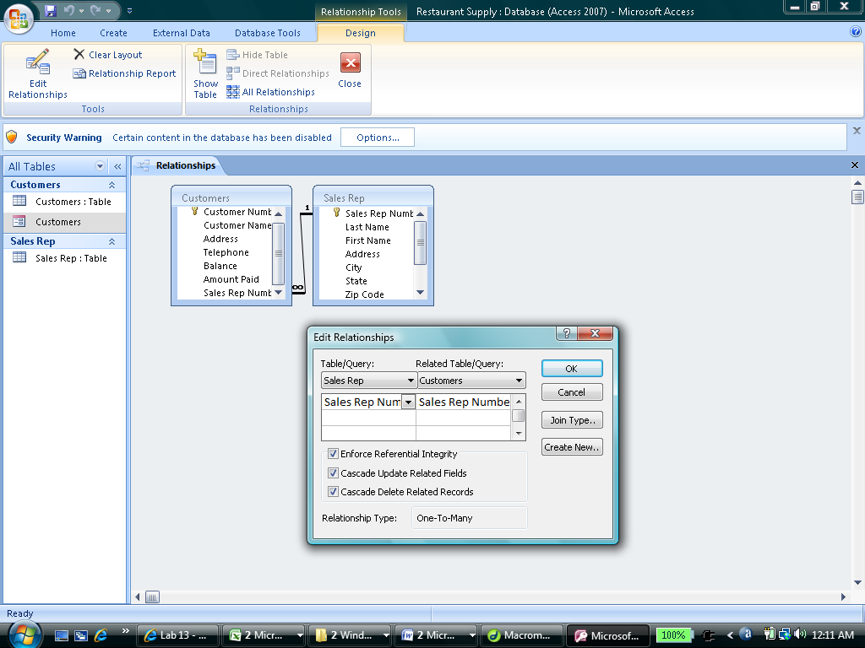
First Query: Display and print the Customer Number, Name, Balance, and Amount Paid fields for all customers where the sales rep number is 51.
- In the main window, select Queries.
- Select Create query in Design View and build query as shown in figure. Print query and label.
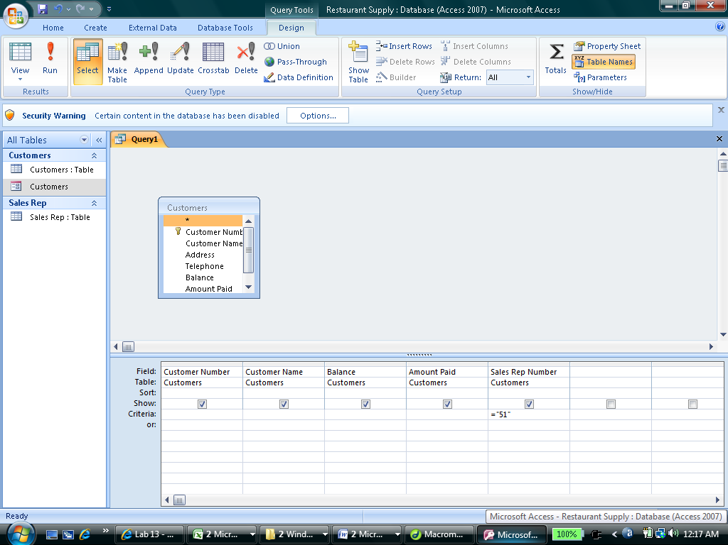
Second Query: Display and print the Customer Number, Name, and Balance fields for all customers where the balance is greater than 100. (Enter criteria: >100) Print query results and label.
Third Query: Display and print the Customer Number, Name, Balance and Amount Paid fields for all customers where the sale rep number is 49 and the amount paid is greater than $1,000. This query is using AND Criteria. All of criteria must be entered in the SAME ROW. Print query results and label.
4th Query: Display and print the Customer Number, Name and Address fields for all customers with an address on Devon. This query is using Wildcard. The asterisk (*) represents any collection of characters. Thus *Devon represent any letters then followed by Devon. Print query results and label.
5th Query: Display and print the Customer Number, Name and Balance fields for all customers where the sales rep number is 49 or the balance less than $50. This query used OR Criteria. Each criteria must be entered in the different rows. Print query results and label.
6th Query: Display and print the Customer Number, Name, Balance, and Amount Paid fields from the Customer table and the First Name, Last Name, and Commission Rate fields from the Sales Rep table. (Hint: Add 2 tables Customer and Sales Rep in this query.) Print query results and label.
7th Query: Same as 6th query, however, restrict the records to only those customers that have a balance of 0. Print query results and label.
- Part 3: - Create queries and reports
Query 8:
Display the Sales Rep Number, Customer Number, Customer Name, Balance, and Amount Paid fields for all customers where the sales rep number is 44 or 49 and the balance is greater than $50.
Create a report based on query 8.
- Create a new report as shown in your text. (Hint: Build the report after creating the query.)
- Select the Layout and Report design you like best.
- Give the report a title such as "Customers of Sales Rep 44 & 49 with balance greater than $50".
- Click Finish.
- Save the report and switch to the Print Preview. (View --> Print Preview)
- Print the report.
Query 9:
- Display the Customer Number, Name, Balance, and Amount Paid fields from the Customer table and the First Name, Last Name, and Commission Rate fields from the Sales Rep table. Restrict records to customers who have balance amount greater 0.
- Create the report for this query.
  - Select all fields available in the query except the First name of Sales Rep.
  - Group by Last Name of Sales Rep.
  - Sort by Customer Name
  - Sum Balance, Amount Paid and Commission
- Print the report.
Create a report that group customers information by each sales representative. The report must also include:
- Sales Rep First and Last Name.
- All of information related to customers.
- Show sub-total balance that each sales representative must ask his customers to settle a payment.
- Give the report an appropriate title, enter date and your names.
- Hint: Create a query that includes all fields from Customer table and First, Last field from Sales Rep table.

- Part 4: - Assemble Project for Turn-in
Assemble in order the following for turn-in:
- Print out of customers data table
- Print out of sales rep data table
- Print outs of queries results for queries 1 – 7.
- Print outs of reports that utilize information from queries 8 and 9.

