CST 134 - Excel Project

Computing Grades for a Class
Part 1: Solution to the Basic Problem
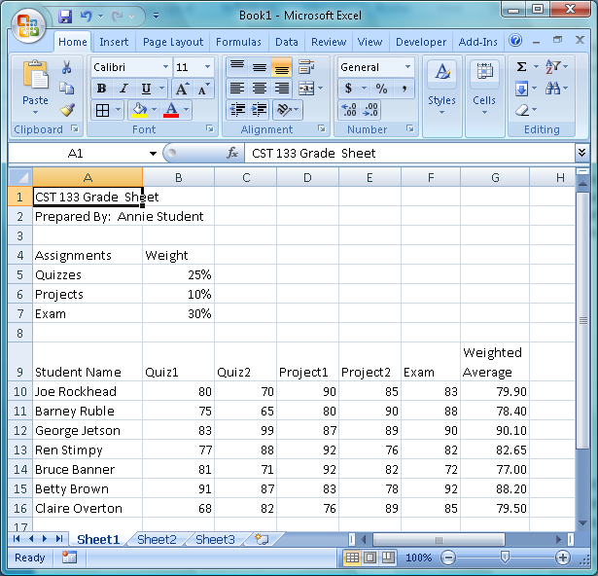
Your mission is to create a spreadsheet that will automate the computation of grades for a fictitious class. The work to be graded in the class in question consists of two quizzes, two lab projects, and a final exam. Each quiz will count 25% of the grade; each lab project will count 10%; the final exam will count 30%. However, the instructor varies these percentages occasionally, so we'd like to construct our spreadsheet so that these values are problem parameters (as opposed to being hard-coded into formulas) which can be easily modified without changing any formulas directly. Begin your project by constructing a spreadsheet that will compute the weighted average for each student in the class. Of course, the spreadsheet should be constructed so that all results are automatically recalculated whenever a grade is changed. The basic layout should look something like the picture (use the data given here when you test your spreadsheet). You will need to use a formula to calculate the “Weighted Average” that uses the assignment weights and the individual assignment scores.
Try changing several of the grades in one of the rows. Check the revised spreadsheet calculation by computing the desired average using your calculator (or by hand) and comparing. If there is a discrepancy, find the error and correct the spreadsheet if necessary. Change the grades back to their original values before proceeding.
Part 2: Adding Some Statistical Summaries
Suppose the instructor finds it convenient to have the average and standard deviation computed for all the grades (tests, projects, exam, and final averages). Use the built-in Excel functions AVERAGE and STDEV to compute these values and add them to the spreadsheet as shown below:
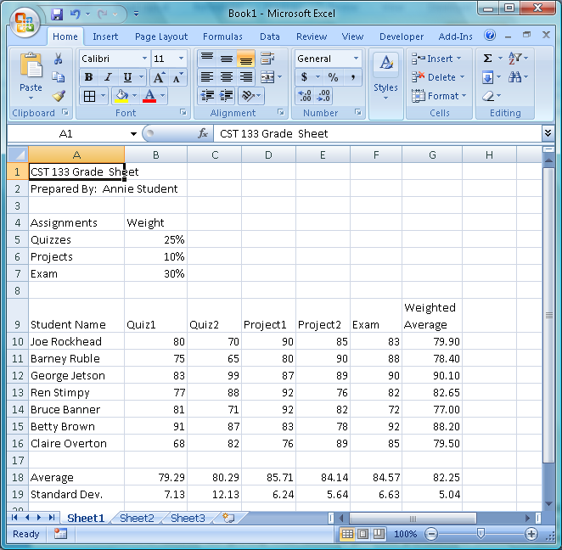

Part 3: Computing Letter Grades
The instructor uses a standard 10-point grading scale, but again may choose to change this scale later. Enhance your spreadsheet to include the calculation of the letter grades using the Excel IF function. Of course, any changes in numerical grades within the spreadsheet should result in automatic recalculation of the grades assigned. Your modified spreadsheet should look something like the following:

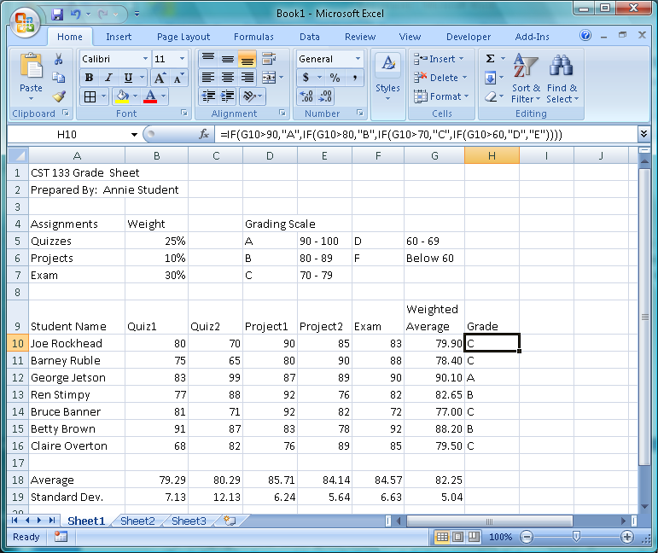
Look closely at the formula bar to see an example of the IF statement used to generate the letter grade values. Your formula may vary slightly depending whether you use the same cell layout. Study the formula and try to understand how it is finding the correct grade based on the IF formula syntax : = if(condition, value-if-true, value-if-false)

Part 4: Adding a Grade Distribution and Histogram
Add an automatic computation of the grade distribution (by letter grade) to your spreadsheet using the Excel COUNTIF function. Once again, look at the example formula in the formula bar to see how the COUNTIF function is used. Once this distribution is calculated, use this data to construct a histogram (column chart) to display the distribution graphically. Display this chart on the sheet (not as a separate sheet). Your sheet should now look something like the following:

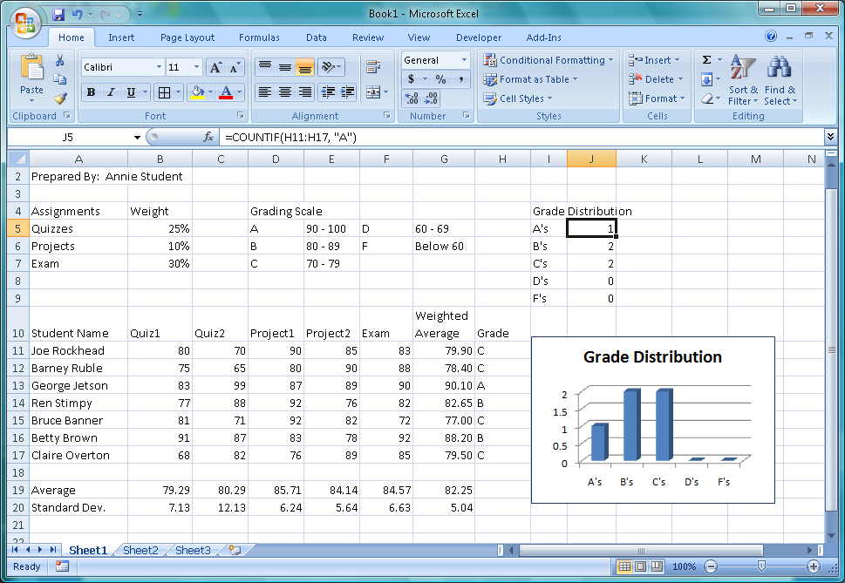
Change some of the numerical test and/or lab project grades in the original data (make the changes drastic enough to be certain some letter grades will change). Observe the corresponding changes in your chart. If these are not consistent with the changes in the letter grades assigned, find the error and correct it. Change the data back to their original values to conclude the project.
Part 5: Make It Look Cool!
Format your sheet. Add some color, play with the headings, background, fonts, etc. Make sure you put your name after the “Prepared By” field.
Turn-in: (your instructor will advise you of the due date)
- After completing your formatting and your happy with the results, print the regular view of the spreadsheet.
- Using the Ctrl + ` (hold down the Ctrl key and press the backtik located above your Tab key), switch to formula view. Print the formula view.

