Designing and Documenting Programs
This lesson teaches students how to analyze a problem statement and develop an algorithm to solve the problem. Students will learn to use program development techniques such as flow-charting and pseudo-code.

Structured Programming
The following list illustrates the majors steps in structured programming:
- Define the problem
- Identify input, output
- Design algorithm
- Develop flowchart, pseudo-code, etc.
- Code the program -- write the program
- Test the program --run it
- Debug the program (fix errors if any)
- Document completed program (final pseudo-code, flowchart, print chart, etc.)

Flow Charting
A flow chart is defined as a pictorial representation describing a procedure. Flow charts provide people with a common language or reference point.
An algorithm is a formula or set of steps for solving a particular problem. To be an algorithm, a set of rules must be unambiguous and have a clear stopping point. Algorithms can be expressed in any language, from natural languages like English or French to programming languages like QBASIC.
We use algorithms every day. For example, a recipe for baking a cake is an algorithm. Most programs, with the exception of some artificial intelligence applications, consist of algorithms. Inventing elegant algorithms -- algorithms that are simple and require the fewest steps possible -- is one of the principal challenges in programming.
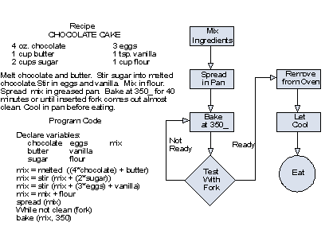
The basic flow charting symbols are illustrated below. Either the oval or circle can be used as the START or TERMINATE symbol.
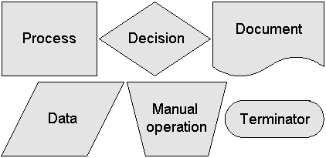
Algorithmic Tools
- Flow chart: (American National Standards Institute -- ANSI symbols:)
- A pictorial representation of program logic
- Parallelogram for input/output
- Oval for start and stop
- Rectangle for processing
- Diamond for decision
- Hexagon for preparations and loops
- Circle for connector
- Arrow for flow direction
Either the oval or large circle can be used as the START or TERMINATE symbol.
A variety of plastic flowchart templates are available to help you create neat, clear flow charts which help to document your programs. An example is shown below.
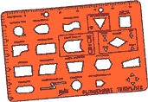
The example bellow illustrates a flow chart for the simple processes and decisions made by a driver in finding the best route home at the end of the working day.
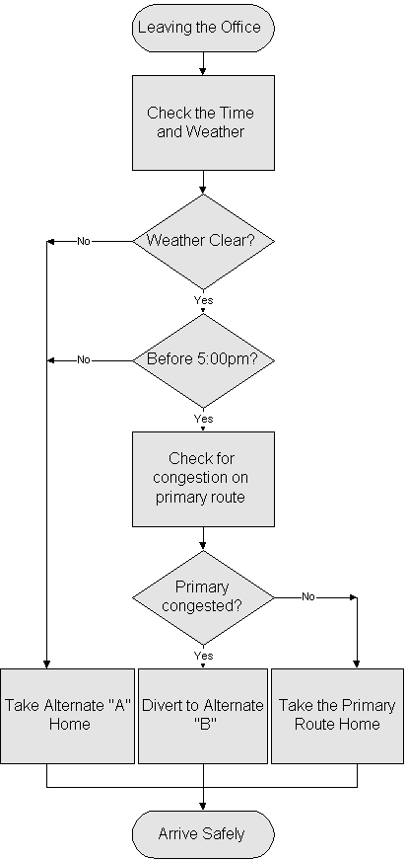

Pseudo-code
Pseudo-code is a cryptic English-like narrative of the program logic. It is an outline of a program or algorithm, written in a form that can easily be converted into real programming statements ... yet is not written in programming statements. For example, the pseudo-code for a bubble sort routine might be written:
while not at end of list
compare adjacent elements
if second is greater than first
switch them
get next two elements
if elements were switched
repeat for entire list
Pseudo-code cannot be compiled nor executed, and there are no real formatting or syntax rules. It is simply one step - an important one - in producing the final code. The benefit of pseudo-code is that it enables the programmer to concentrate on the algorithms without worrying about all the syntactic details of a particular programming language. In fact, you can write pseudo-code without even knowing what programming language you will use for the final implementation.
Pseudo-code should not include keywords in any specific computer languages. It should be written as a list of consecutive phrases. You should not use flowcharting symbols but you can draw arrows to show looping processes. Indentation can be used to show the logic in pseudo-code as well. One programmer should be able to take another programmer's pseudo-code and generate a program based on that pseudo-code.
Caution
Never write your program before either flowcharting or pseudo-coding it.
The programming process is a complicated one. You must first understand the program specifications, of course, Then you need to organize your thoughts and create the program. This is a difficult task when the program is not trivial (i.e. easy). You must break the main tasks that must be accomplished into smaller ones in order to be able to eventually write fully developed code. Writing pseudo-code WILL save you time later during the construction and testing phase of a program's development.
Sample Pseudo-code
Input number1, number2
Sum = number1 + number2
Display heading message “Number1, Number2, Sum”
Display number1, number2, Sum
End
When you begin to write pseudo-code for a specific program, you may want to make a list of the main tasks that must be accomplished on a piece of scratch paper. Then, focus on each of those tasks. Generally, you should try to break each main task down into very small tasks that can each be explained with a short phrase. There may eventually be a one-to-one correlation between the lines of pseudo-code and the lines of the code that you write after you have finished pseudo-coding.

