**Chapter 14 Lab**

**Applets and More**

# Lab Objectives

* Be able to write an applet
* Be able to draw rectangles, circles, and arcs
* Be able to override the paint method
* Be able to use a timer

# Introduction

In this lab we will create an applet that changes the light on a traffic signal. The applet that you create will draw the outside rectangle of a traffic signal and fill it in with yellow. Then it will draw three circles in one column, to resemble the red, orange, and green lights on the traffic signal. Only one circle at a time will be filled in. It will start will green and cycle through the orange, red, and back to green to start the cycle again.

However, unlike a traffic signal, each light will remain on for the same amount of time. To accomplish this cycle, we will use a timer object.

When you have finished your applet should appear as shown in figure 1, but with the filled in circle cycling up from green to orange to red and starting over in a continuous changing of the traffic light.

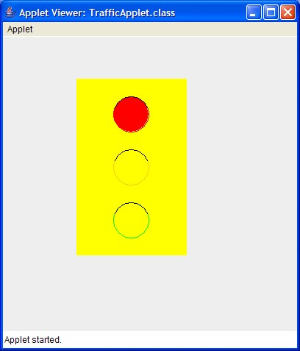

73

# Task #1 Create an Applet

1. Copy the file TrafficApplet.java (see code listing 14.1) from the Student CD or as directed by your instructor.
2. This class currently has all the constants you will need to be able to you’re your traffic signal. It doesn’t have anything else. You will need to change the class heading so that it extends JApplet.

# Task #2 The Timer

1. An applet does not have a constructor or a main method. Instead, it has a method named **init** that performs the same operations as a constructor. The **init** method accepts no arguments and has a void return type. Write an **init** method.
2. Inside the **init** method, create a timer object passing in the TIME_DELAY constant and a new TimerListener (We will be creating the listener class next).
3. Call the start method with the timer object to generate action events.

# Task #3 The TimerListener Class

1. Write a private inner class called TimerListener which implements ActionListener.
2. Inside this class, write an actionPerformed method. This method will check the status variable to see whether it is currently red, orange, or green. Since we want the lights to cycle as a traffic signal, we need to cycle in the order: green, orange, red, green, orange, red, … Once the status is determined, the status should then be set to the next color in the cycle.
3. Redisplay the graphics components (to be created next) by calling the **repaint** method.

# Task #4 Drawing Graphics

1. Draw the traffic signal by overriding the paint method. For all graphics, use the named constants included in the class.
2. Call the method that is being overridden in the parent class.
3. Create a yellow rectangle (solid color) for the traffic signal. The constants

X_TRAFFICLIGHT, Y_TRAFFICLIGHT, TRAFFICLIGHT_WIDTH, and TRAFFICLIGHT_HEIGHT have already been defined for your use.

1. Create round lights of red, orange, and green for the signals. These should be outlines of these colors. The constants X_LIGHTS, Y_REDLIGHT,

Y_GREENLIGHT, Y_ORANGELIGHT, and LIGHT_DIAMETER, have already

been defined for your use. Only one light will be filled in at a time, when the status indicates that one has been chosen. You will need to check the status to determine which light to fill in. Remember, the status is changed only in the

74

actionPerformed method (already defined) where the **repaint** method is also called.

1. Put the shade hoods above the lights by drawing black arcs above each light. The constants HOOD_START_ANGLE and HOOD_ANGLE_SWEPT have already been defined for your use.
2. Try out your applet. If time permits, create a web page on which you can display your applet.

**Code Listing 14.1 (TrafficApplet.java)**

import java.awt.*; import java.awt.event.*;

import javax.swing.*;

public class TrafficApplet

{

public final int WIDTH = 300;

public final int HEIGHT = 400;

public final int X_TRAFFICLIGHT = WIDTH/3; public final int Y_TRAFFICLIGHT = HEIGHT/7; public final int TRAFFICLIGHT_WIDTH = WIDTH/2; public final int TRAFFICLIGHT_HEIGHT = HEIGHT*3/5; public final int LIGHT_DIAMETER = TRAFFICLIGHT_HEIGHT/5; public final int HOOD_START_ANGLE = 20; public final int HOOD_ANGLE_SWEPT = 140;

public final int X_LIGHTS =

TRAFFICLIGHT_WIDTH/3 + X_TRAFFICLIGHT;

public final int Y_REDLIGHT =

TRAFFICLIGHT_HEIGHT/10 + Y_TRAFFICLIGHT;

public final int Y_ORANGELIGHT =

TRAFFICLIGHT_HEIGHT*4/10 + Y_TRAFFICLIGHT;

public final int Y_GREENLIGHT =

TRAFFICLIGHT_HEIGHT*7/10 + Y_TRAFFICLIGHT;

public final int TIME_DELAY = 1000;

private String status = "green"; //start with the green light private Timer timer; //will allow lights to cycle

}

**Paste in the source code of your applet program here:**

**Paste in a screenshot of your applet here:**

**Upload the completed assignment to the lab 11 dropbox for grading**.